1. Go to<https://login.canvas.cornell.edu/>

2. Login with Cornell NetID

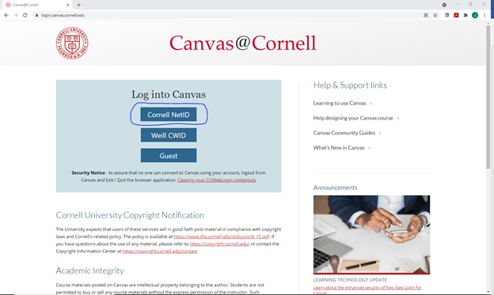

3. Click Courses

4. Select “CCSS Software Access”

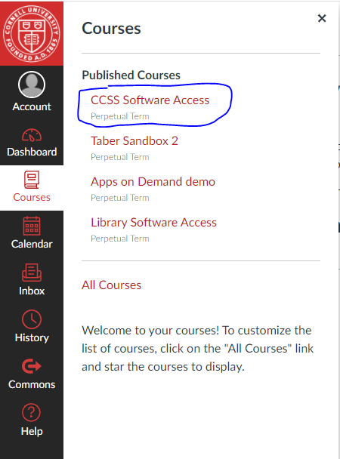

5. Once inside course select button “Apps on Demand - Statistics Software”. This will launch the resource where you can use the software

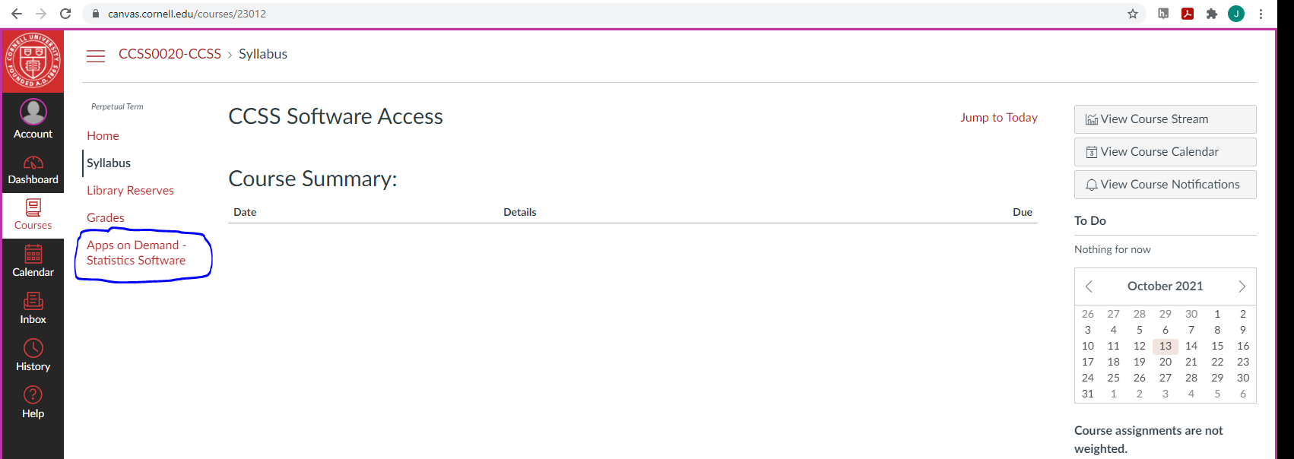

6. Select software

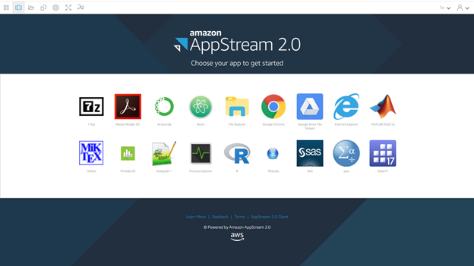

7. Copy and Paste. <https://it.cornell.edu/appsondemand/copy-and-paste-non-chrome-browsers-apps-demand?utm_source=sidebar>